**Assignment 16**

**Task 1. Create a DAX measure such that data should be showed to the users only if something is searched on the slicer.**

Step 1. Select 1 slicer , 4 Card, 1 funnel,1 donut Chart and 1 Barchart from Visualization

Step 2. Creating following DAX measures

Title = IF ( HASONEVALUE ( 'Student Survey'[Store Setting] ), "Displaying the Data by Selected Values", "Choose the Value from Above Slicer" )

Toy = If(HASONEVALUE('Student Survey'[Store Setting]),SUM('Student Survey'[Toys]),BLANK())

Total Amount of Purchase = If(HASONEVALUE('Student Survey'[Store Setting]),SUM('Student Survey'[Total Amount of Purchases]),BLANK())

Video Games = If(HASONEVALUE('Student Survey'[Store Setting]),SUM('Student Survey'[VideoGames]),BLANK())

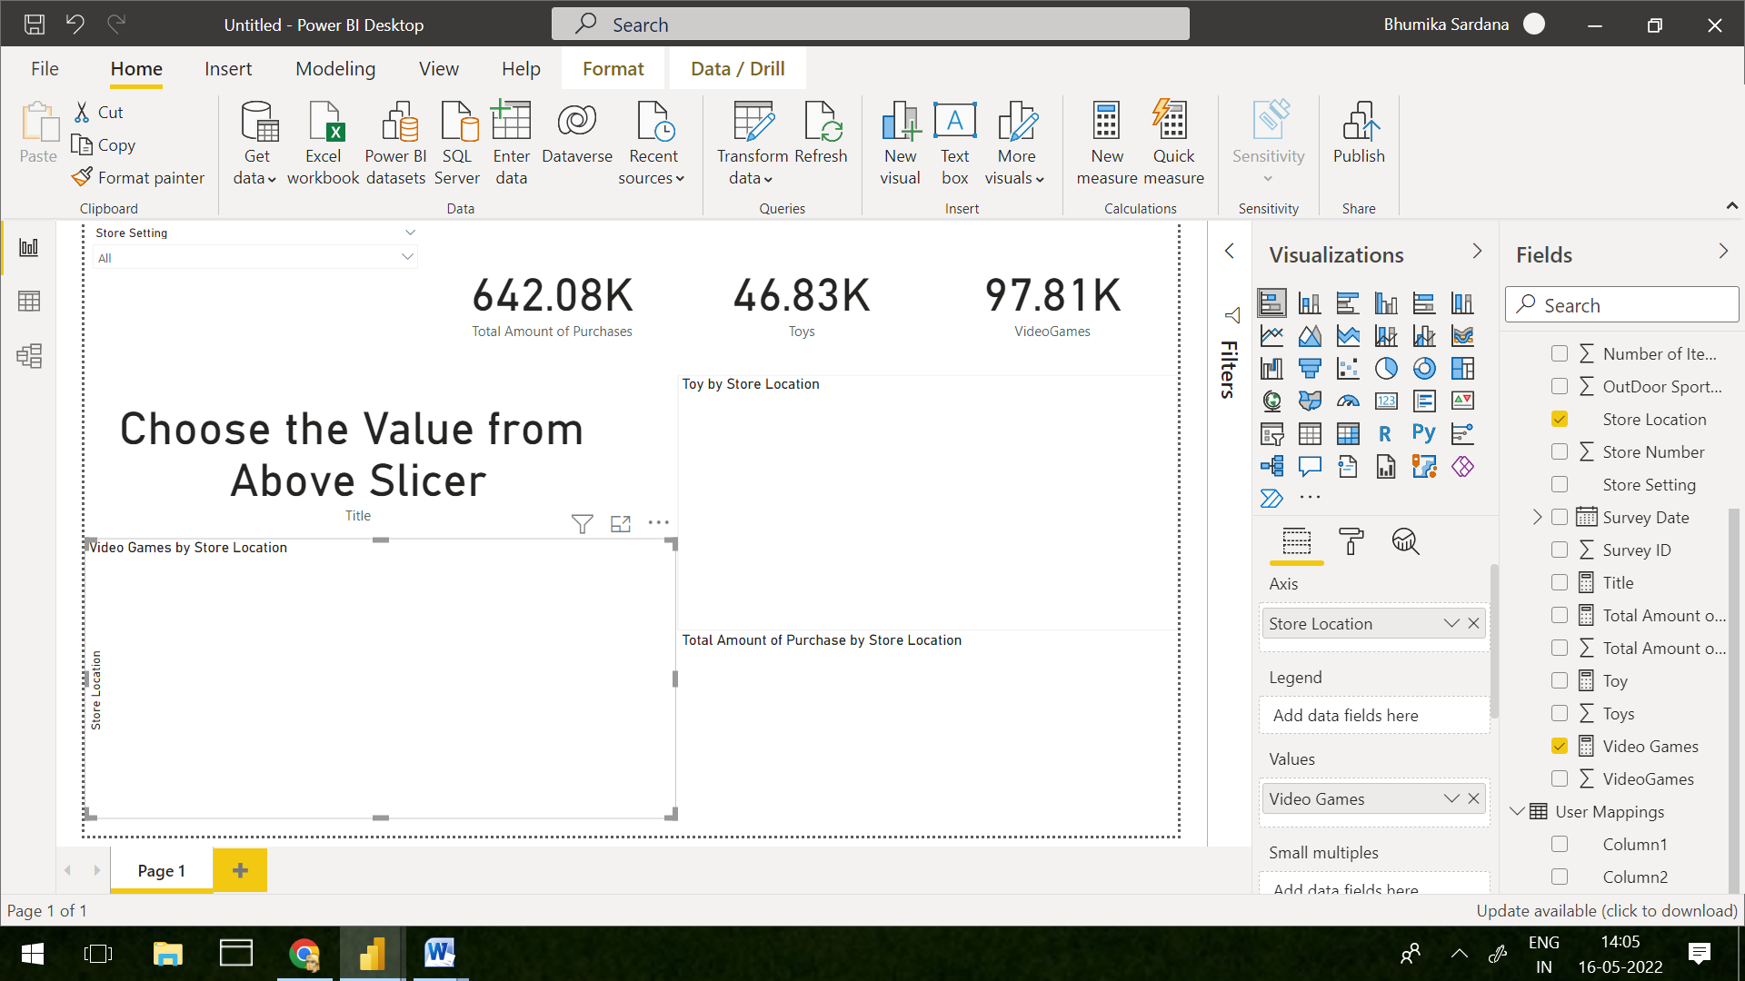

Step 3. Add column and Measure in visual as followed

StoreSetting -> Field (Slicer)

TotalAmountOf Purchase->Fields(Card)

Toys ->Fields(Card)

VideoGames->Fields(Card)

Title(Measure)->Fields(Card)

StoreLocation->Group, Toy(Measure)->Values(Funnel Chart)

StoreLocation->Legend, Total Amount Of Purchase(Measure)->Values(Donut Chart)

StoreLocation->Axis,VideoGames(Measure)->Values(BarChart)

Step 4. Select Value in Slicer

